CHANGING STATES

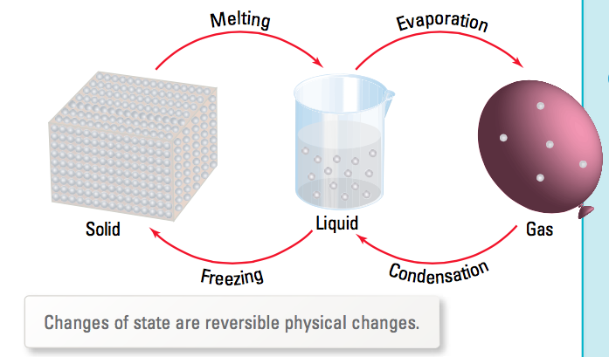

MELTING
• Change from solid to liquid.
• Particles gain enough energy to break away from their fixed
positions.

BOILING
• Change from liquid to gas.
• Particles gain enough energy to overcome any attraction for other
particles.

CONDENSING
• Change from gas to liquid.
• Particles lose heat energy and move closer together.
• Attractive forces pull them together.

FREEZING
• Change from liquid to solid.
• Particles lose energy, move closer together and attractive forces
hold them in fixed positions.

SUBLIMATION
• Change from solid to gas (or gas to solid) without a liquid phase.

e.g. Dry ice (solid carbon dioxide) goes straight to a gas, hence it
is “dry” (no liquid).

EVAPORATION
• Change from liquid to gas at a temperature below the boiling
point.
• Occurs from the surface of a liquid.
(Compare with boiling which occurs at the boiling point only and
from within the liquid.)

If the attractions among the particles of a substance are weak, the substance is a gas at room temperature.

e.g. Oxygen and carbon dioxide are gases.

It the attractions are strong, the substance is a liquid or solid at room temperature.

e.g. Mercury is a liquid metal, steel is a solid metal.

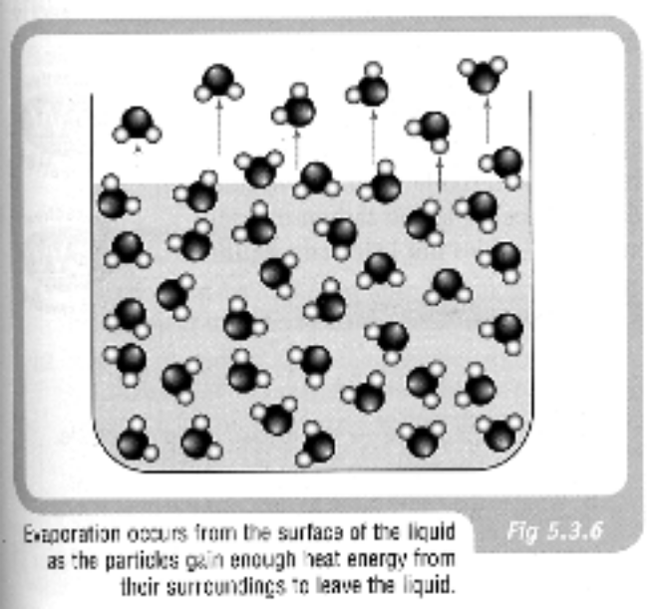
CHANGES OF STATE AND TEMPERATURE

When a substance changes phase, no temperature change occurs to it.

Instead, heat is being used to change the distance between the particles (either closer together (freezing or condensing) or further apart (melting or boiling.

This heat is called latent heat (meaning "hidden heat") as no temperature change is measured.

Example

Consider the graph below which shows a cooling curve for water initially at about 40 °C.

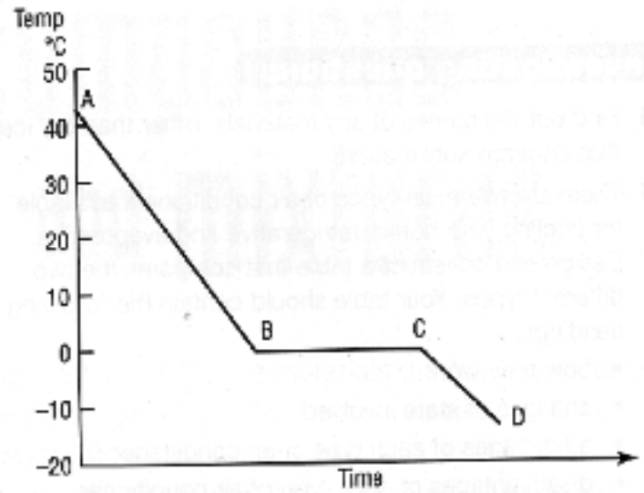

Section AB: shows the water cooling as heat is removed.

Section BC: water freezes as heat is removed and particles move
closer together.

Section CD: ice continues to lose heat and drops below zero.

